Programme Report of Vidyasagar Jonmo Jayanti (online)
No. Of event  (Date wise) | 26/09/2020
Title of the Event | Vidyasagar:Kaale o Kalanrare
Objectives | To commemorate the relevance of Ishwarchandra Vidyasagar’s contribution to the women’s social, economic and cultural upliftment.
Date & Duration | 26/09/2020  10.30 am -2 pm
Level of Event (College / State / National / International) | State
No. of Participants | 185
Description of event | Maharani Kasiswari College, Department of Bengali, observed the extended bi-centennial of the great nineteenth century Bengali social reformer, Ishwarchandra Vidyasagar. The college organised a series of online lectures,events, competitions on this occasion.The inaugural song was sung by Dr.Sayanti Bhaumik(Assistant Professor, Department of Education) and Professor Anuja Seth delivered the keynote address.The inaugural speech was given by the respected Principal Dr.Sima Chakrabarti.An book titled Vidyasagar was released online.The welcome address was delivered by Prof.Gobinda Mondal, the convenor of the webinar and Head of the Department, Bengali.Dr.Tapan Kumar Chand, convenor of IQAC extended his warm wishes for the event.The resource persons Dr. Nirmal Bandopadhyay (Teacher and research scholar, Sodepur High School) and Dr Siddhartha Dutta, Assistant Professor,Chakdaha College delivered their speech.  This was followed by screening of snippets from the movie Vidyasagar .The College revisited the bi-centennial celebration held in the college in 2019.The results of the intra-college were announced by the Principal Dr.Sima Chakrabarti, Prof.Sunanda Mukherjee and Shri Anindya Basu.An essay writing competition was held.The Principal gave the vote of thanks.
Event Notice | 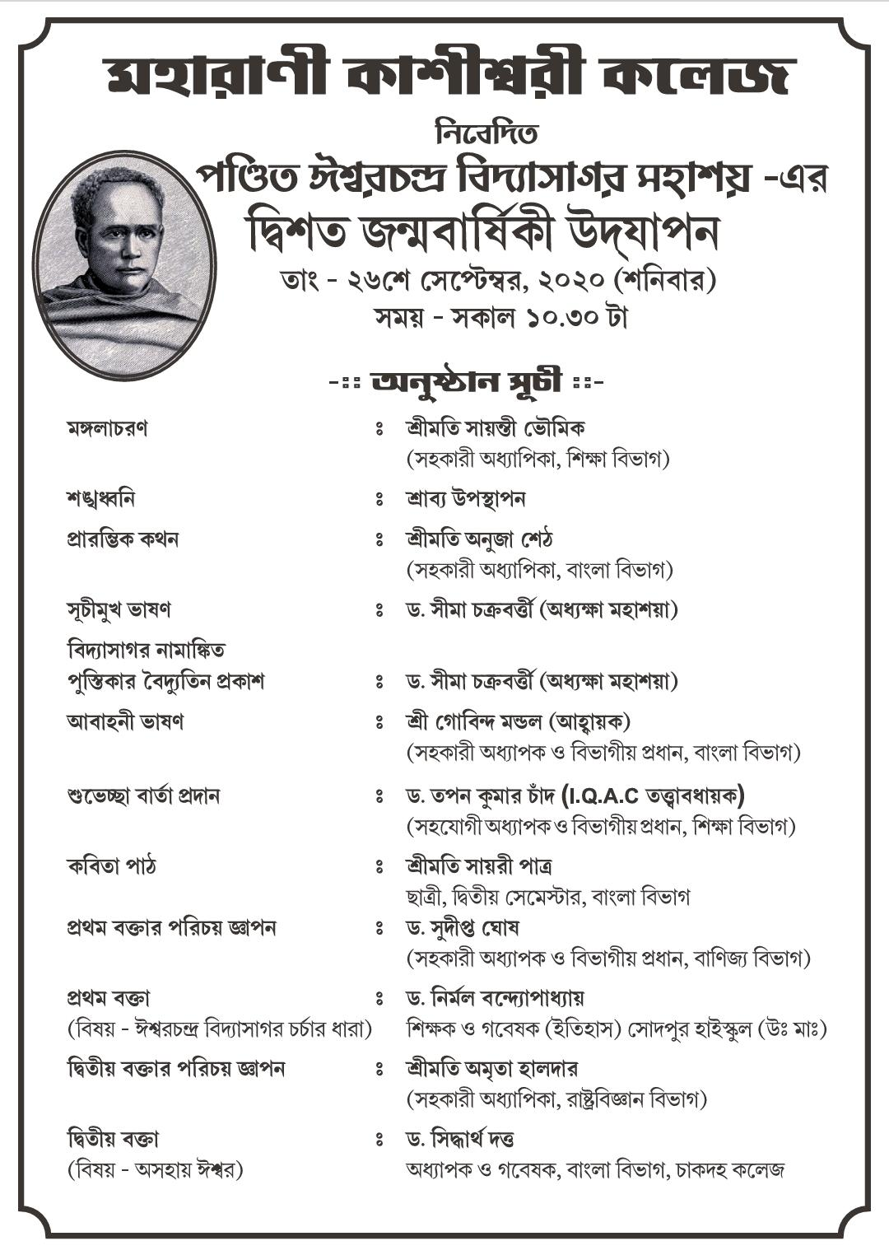
Programme schedule | 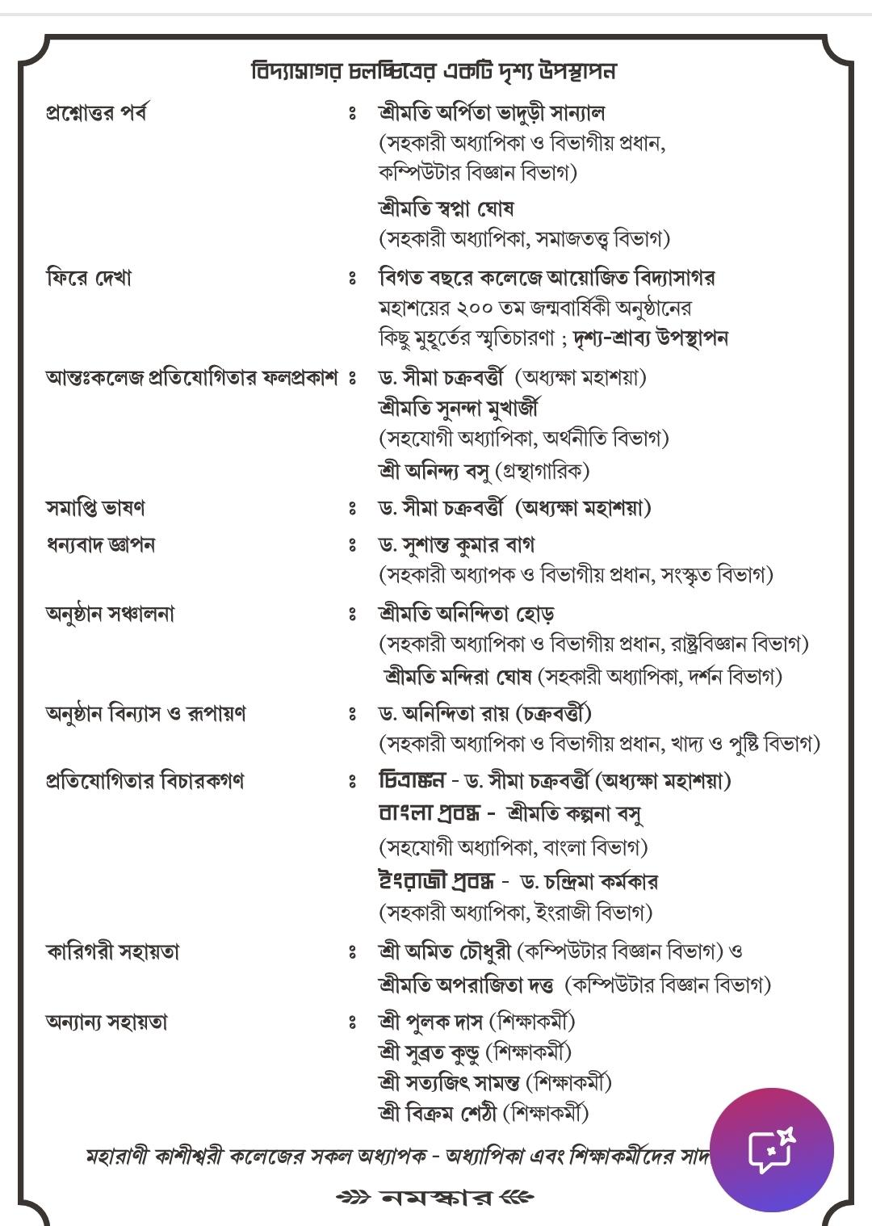
Attendance sheet | 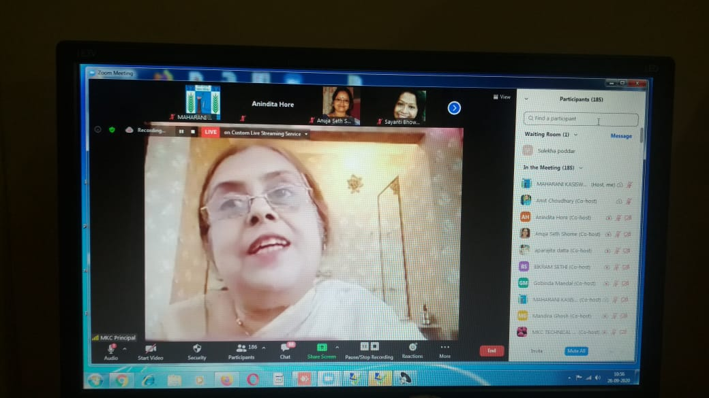
Event Pictures | 